Ideation Phase Empathize & Discover

Date | 27 February 2026
Team ID | LTVIP2026TMIDS66231
Project Name | IntelliSQL: Intelligent SQL Querying with LLMs using Gemini Pro
Maximum Marks

Empathy Map Canvas:

The IntelliSQL Empathy Map focuses on understanding the needs, experiences, and motivations of data analysts, developers, database administrators, and business users who interact with relational databases. These individuals are deeply committed to extracting meaningful insights from data but are often hindered by the complexity of SQL syntax, schema navigation, and query optimization when working with large-scale databases powered by intelligent LLM-driven querying using Gemini Pro.

Example:

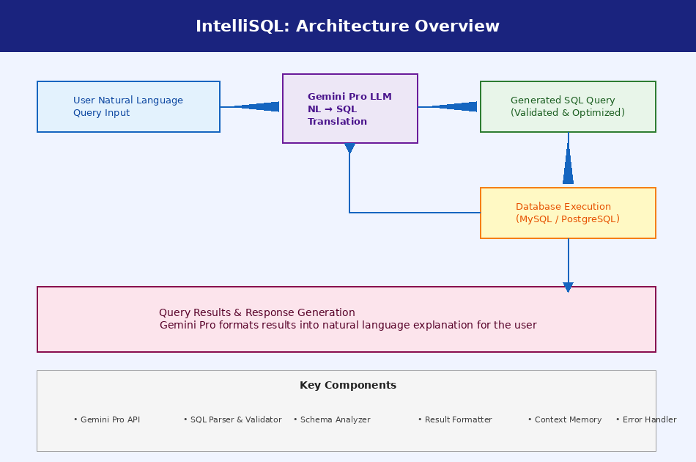

Example: IntelliSQL: Intelligent SQL Querying with LLMs using Gemini Pro

